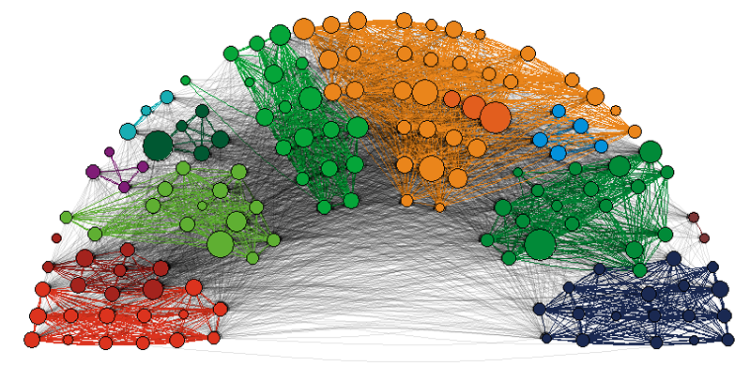

**Panel a.** Follower relations

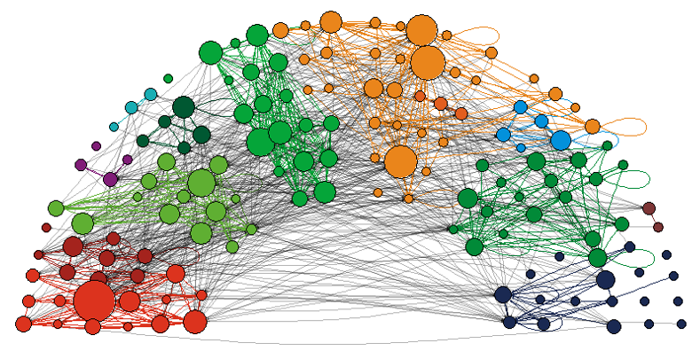

**Panel b.** @-mentions

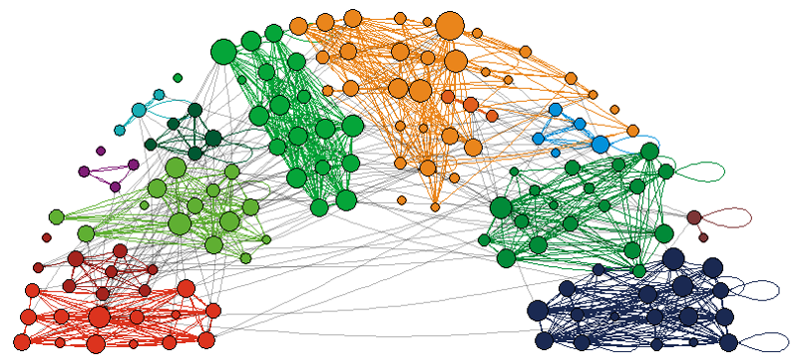

**Panel c.** Retweets

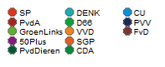

**Figure 1.** Directed twitter relations between Dutch MPs (2017)

*Notes: Node size based on degree. Edge color based on Party affiliation, black if MPs from different party*